CS420 (Solved Sample Paper 2024)

Web Development for Portable Devices

Subjective Questions (3 Marks)

Question
Define a touch-sensitive div to which you can attach an event listener and also define a div at the top where you will display the screen coordinates of the most recent touch.
Answer:
We define a touch-sensitive div to which we will attach an event listener. We also define a div at the top where we will display the screen coordinates of the most recent touch.
Next we add some JavaScript to register the event listener, and add a handler function to do something with the touch data: } So, here we’re simply identifying the touchzone div, attaching a listener for the touchstartevent, and registering a handler function: touchHandler.
In the touchHandler function we grab the x and y coordinates of the touch, and write them to the coords div.

Question
What are Pointer Events, and write their description as well?
Answer:
Pointer event are as following:
- pointerdown
- pointerenter
- pointerleave
- pointermove
- pointerout
- pointerover
- pointerup
(Also write their description)

Question
What are virtual keyboards?
Answer:
Phones and tablets do not have the benefit most desktops and laptops do, which is a large input device called the "keyboard". Virtual keyboards offered by mobile devices are physically smaller and usually more tedious to operate, but the great news is that HTML5 has already standardized a handful of input types which make them easier to use.
Input Types in HTML5: search, email, url, tel number, range, date, month, week, time, datetime, datetime, local, color.

Question
Write touch handler guide lines.
Answer:
It is good practice To use as few handlers as necessary in your application and keep the areas with touch handlers as tightly constrained as you can. That way the default scrolling mechanisms can take over as much as possible.

Question
Write any three pointer attributes.
Answer:
Pointer attributes are as following:

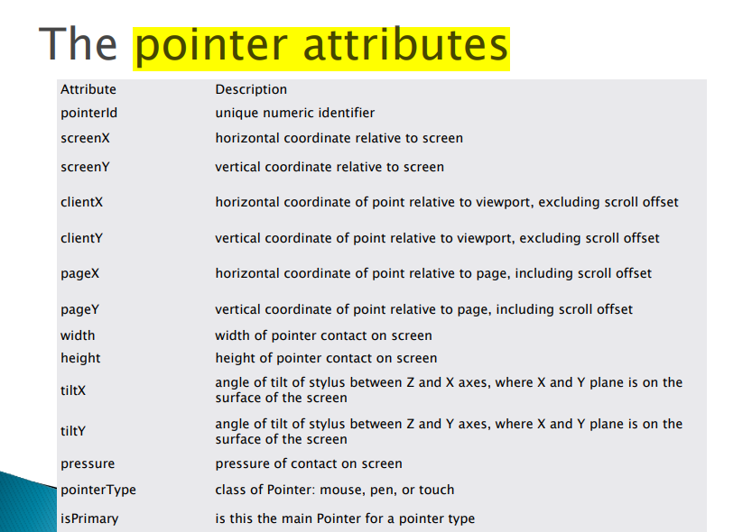

Question
Write any three event types.
Answer:

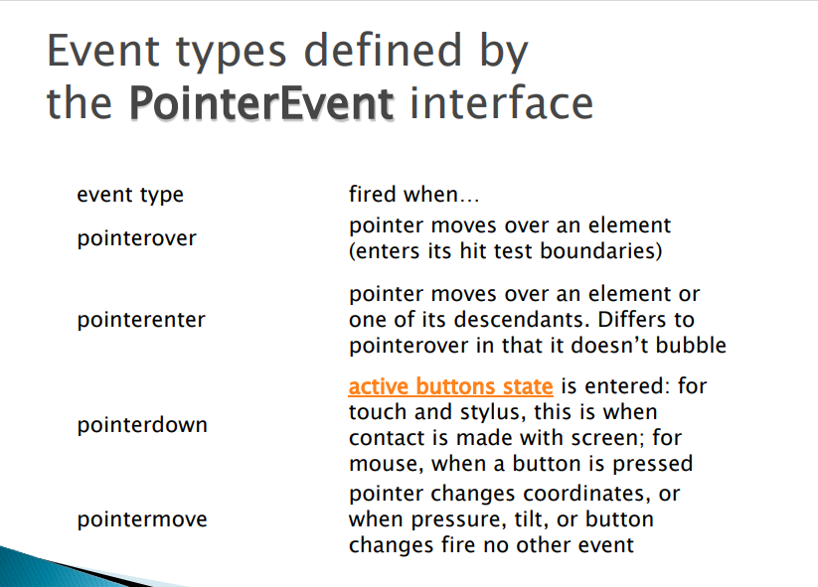
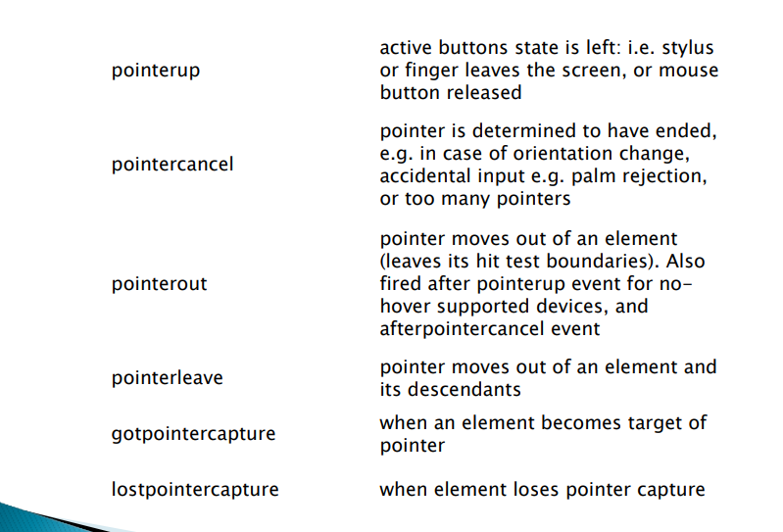

Subjective Questions (3 Marks)
Question#1
Write any five input type names in HTML5.
Answer:

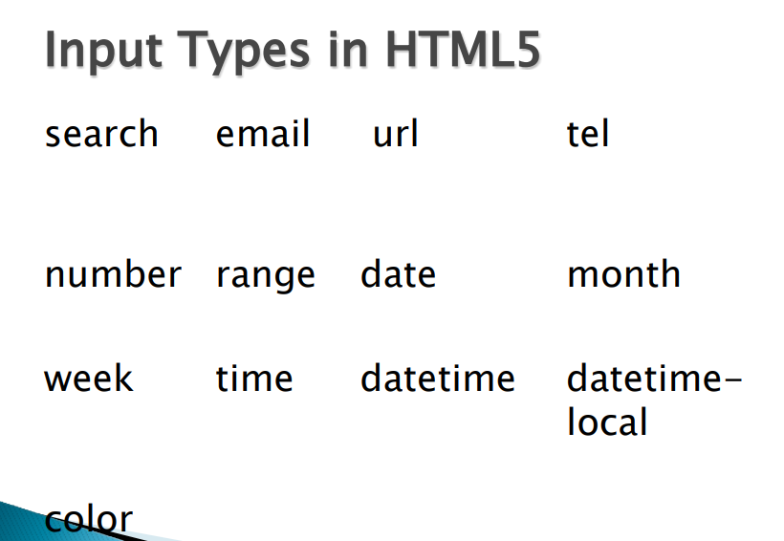

Question#2
Write at least three important features of input.
Answer:
There are two more features in inputs.
- The required attribute
- The place holder attributes.
The other feature, is the placeholder text. You may want to give hints to your users. In some fields, they go away when they start typing. You can do that pretty easily by just setting a placeholder attribute. Placeholder Text } The placeholder attribute specifies a short hint that describes the expected value of an input field (e.g. a sample value or a short description of the expected format). } The short hint is displayed in the input field before the user enters a value. } Note: The placeholder attribute works with the following input types: text, search, url, tel, email, and password.
The required attribute: Required just lets me say, this field is required before you can submit the form.
For example, if I want to make sure that a user enters the username. Now if user will try to submit this form without entering the username he will get the error message

Question#3
What is Telecolon URL, and write its syntax?
Answer:
On mobile, you can use a telecolon URL to create a URL that when activated will actually dial a telephone number. This is a really handy feature, particularly for business websites. Customers can instantly dial you. } Of course, on desktop, these URLs will typically fail, so you probably want to deactivate them.
Syntax:
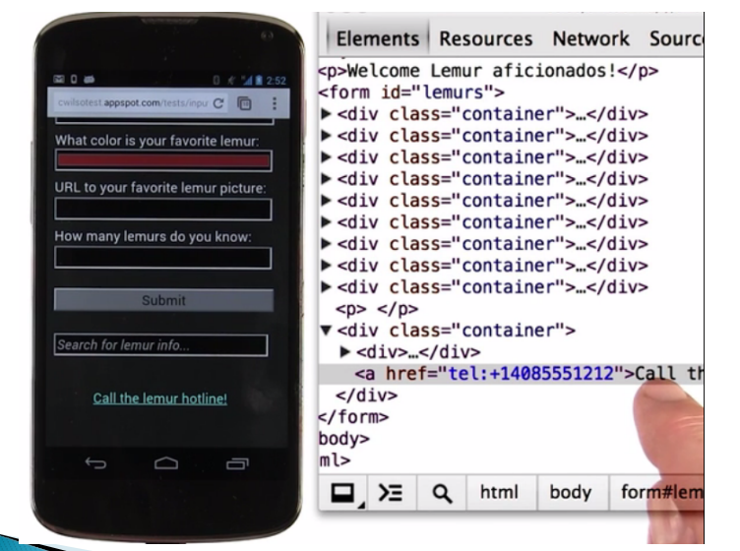

Question#4
Write any five sensor names that can be found today in mobile phones.
Answer:
The phone has a camera that can take stills and video, has audio input and output. It has a GPS, a compass, a tilt sensing accelerometer. A Mobile device has far more sensors than a desktop or laptop typically has. And all this, in a device that one can typically hold in the palm of his/her hand. This enables the mobile platform to play host to incredibly engaging and interactive user experiences. You can capture a QR code to transfer a hyperlink. taking pictures and making videos can be done with camera as well as we capture a map or a business card.
(From google):
Here are five common sensors that can be found in modern mobile phones:
Accelerometer: This sensor detects changes in acceleration and movement. It’s used for features like auto-rotation of the screen, step counting, and gaming interactions1.
G-Sensor: Similar to the accelerometer, it measures acceleration in three dimensions (x, y, and z). It’s commonly used for step tracking and detecting phone orientation1.
GPS (Global Positioning System): Responsible for precise location tracking, it’s used by mapping apps and other location-based services2.
Ambient Light Sensor: Adjusts screen brightness based on the surrounding light conditions, optimizing battery life and user experience3.
Proximity Sensor: Detects how close your phone is to your face during calls, allowing it to turn off the screen to prevent accidental touches1.

